SKILL-17
- To Implement how to List Active Jobs, Display Status Information, Retrieve Job IDs, Format Output, Update State Information, Test Job Listings.
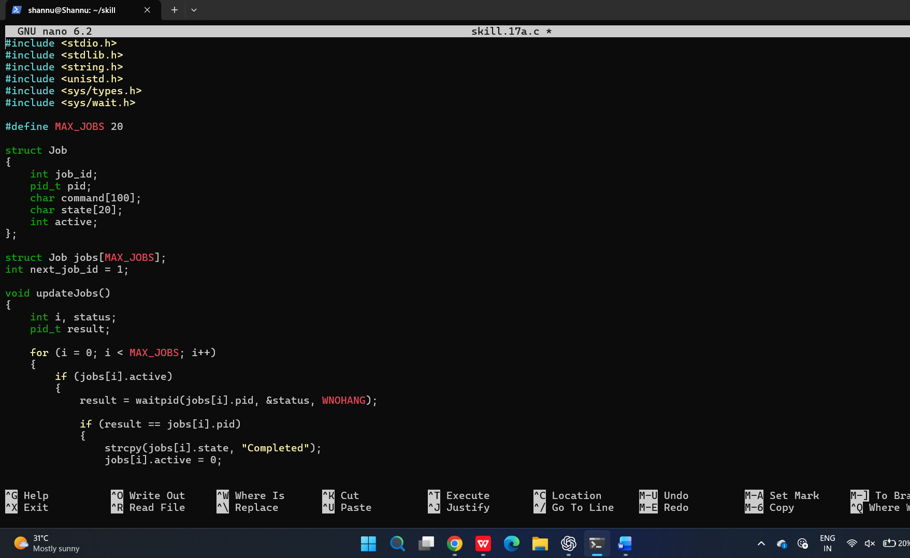
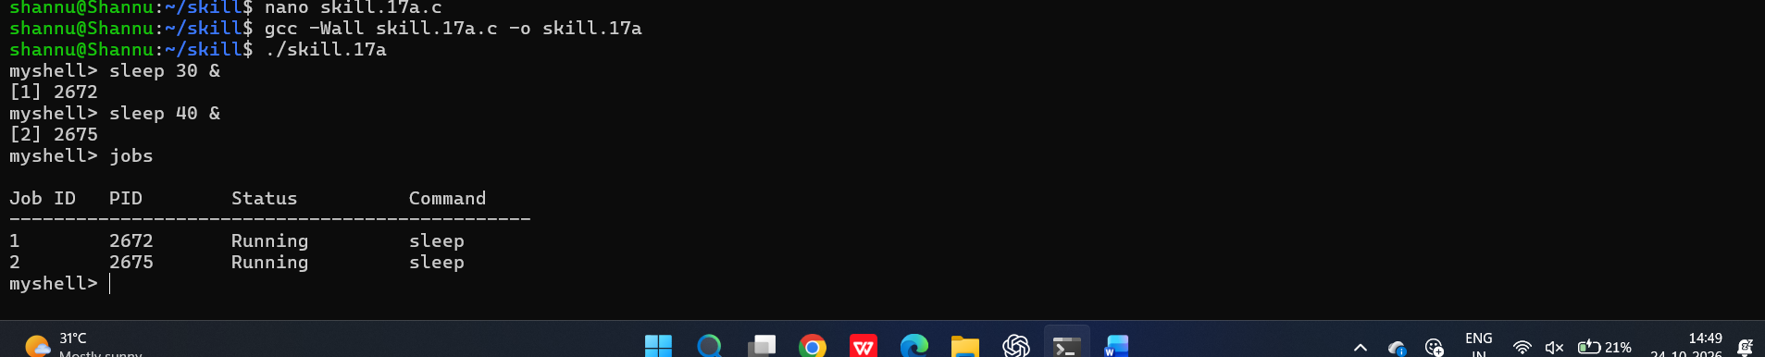

To design how to Identify Target Job, Transfer Terminal Control, Resume Processes, Wait for Completion, Update Job State, Test Foreground Switching.
